**Network introduction:**

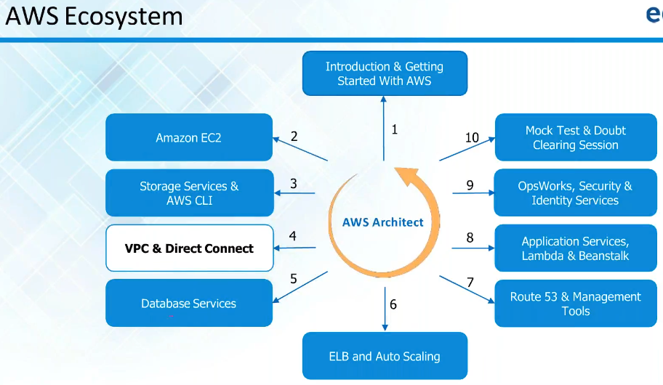

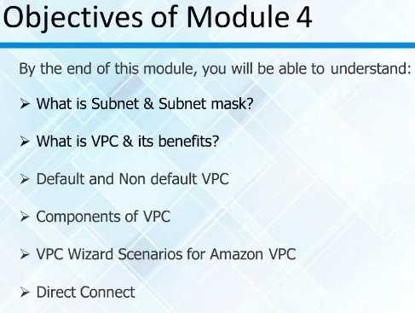

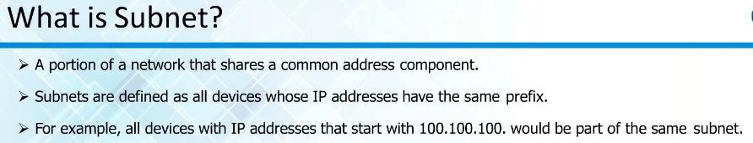

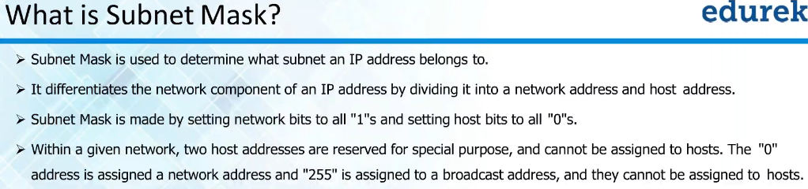

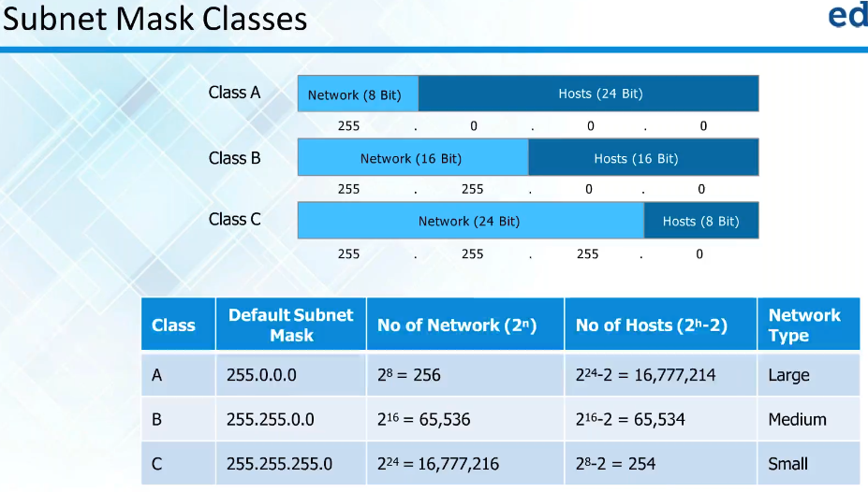

**VPC:**

* AWS is a public cloud
* Every company like to have private network as it will be inside the organisation and can be managed by them and there will be strong security as well
* Having a private network setup over a public setup virtually which is called virtual private cloud
* There will be default VPCs running
* We will be launching instances in VPC
* When we launch AWS, you will be launched inside default VPC
* If we create a VPC apart from default. We call it as non-default VPC or custom VPC

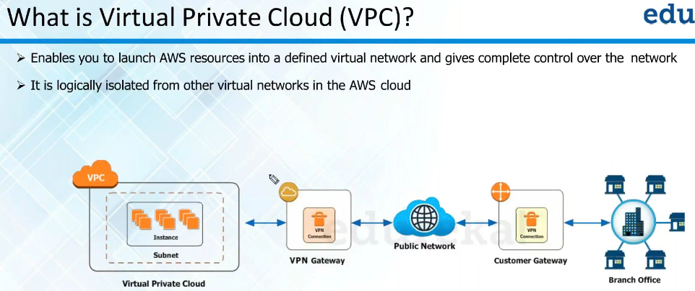

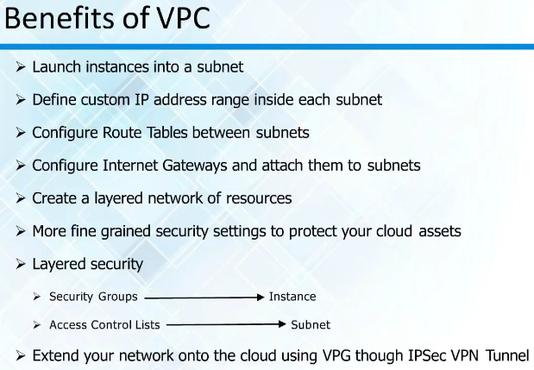

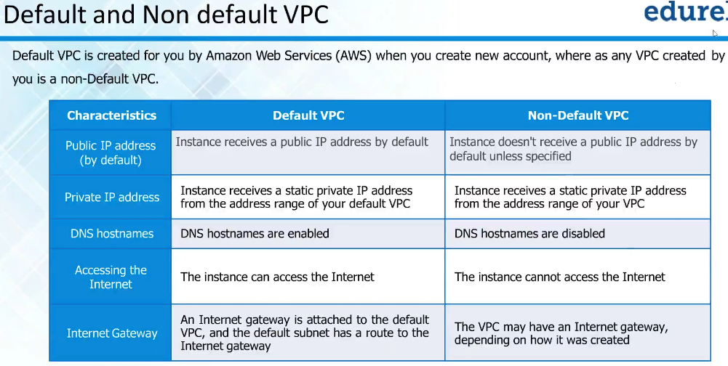

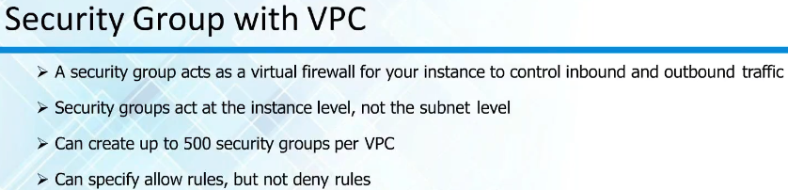

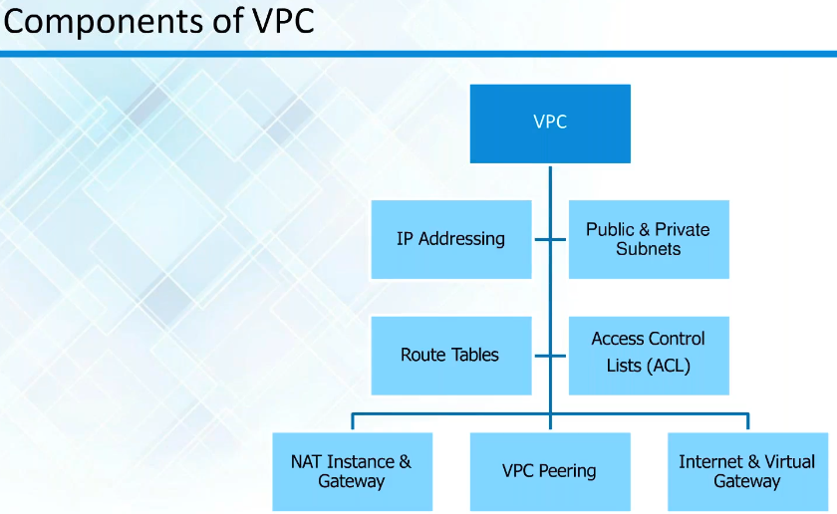

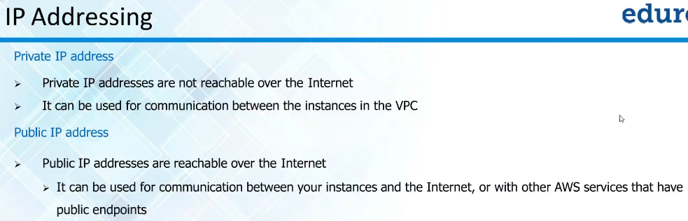

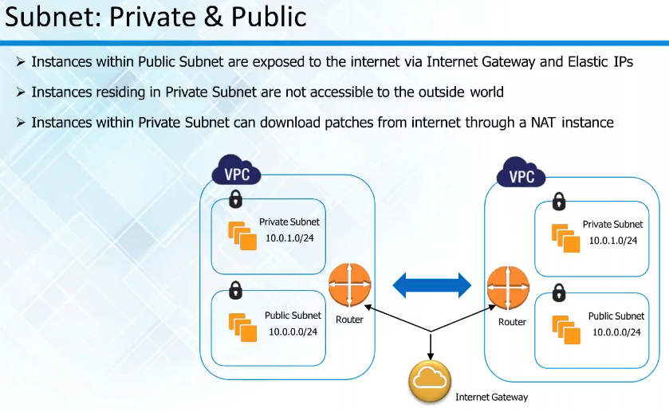

* VPC is virtual private cloud and subnets are smaller networks inside VPC and we launch resources inside subnets
* We use subnets for security and easy to use for different purposes
* We cannot get internet connection to the private IP as we don’t know if it is a unique IP or not
* So, we need ISP help to get unique public IP address and we can use it
* So, it used the public address when it needs internet access

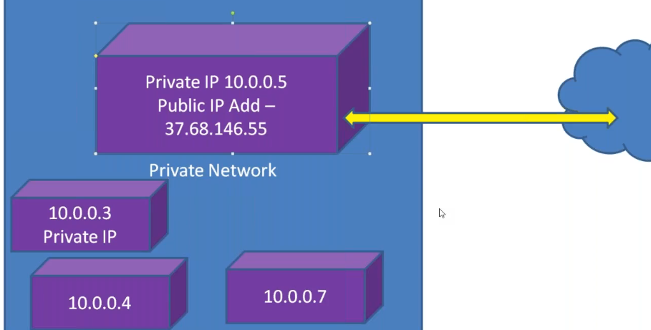

* We create public and private subnet and add the servers in public subnet which requires internet access and add servers in private subnet which doesn’t

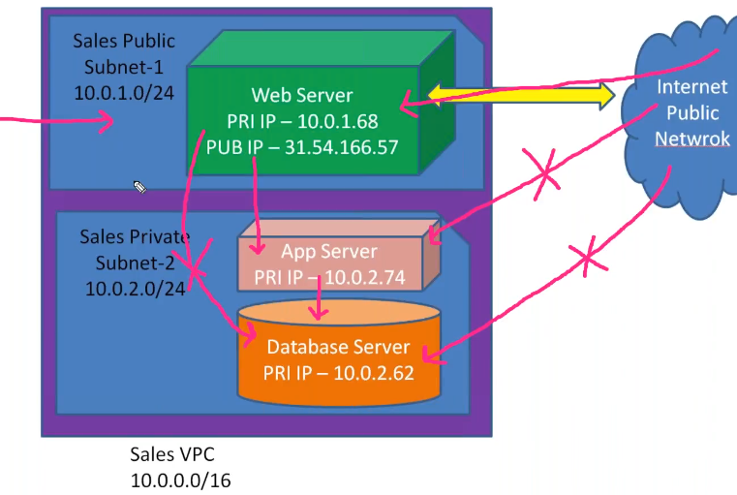

* This is also called multi-tier architecture